West Lancashire Adult Training & Support
Application Form

Name of course Module 25 Assessing Learning

Date of course Monday 2nd April 2012

Time of course 7.15pm for a 7.30pm start

Venue 1st Kirkham & Wesham Scout Headquarters

Cost £6 for Training Materials (cheques to “WLCSC/LT” please)

Closing date for applications Wednesday 28th March 2012

To book on the above course please complete the information below and return as indicated. Uniform is not required on this occasion and refreshments will be provided.

The evening will last approximately 2hours and is aimed at those wishing to become a training advisor and / or training assessor as well as serve as a re-cap for those that have previously undertaken Module 25 training but not put it in to practice. The session will cover the requirements for guiding a learner through The Scout Association Adult Training Scheme, the validation process methods and associated paperwork.

If you need any further information relating to this please contact Fiona using the details below.

-------------------------------------------------------------------------------

Module 25, Monday 2nd April 2012

Full Name (Mr / Mrs / Miss)
Postal Address including postcode

Email Address
Telephone Number (including STD code) and Mobile number

Special Needs (eg. Mobility/diet)
Any medical conditions we should know about?

District |  |  | Group
Current position in Scouting

Emergency Contact Name, Address, Phone (in case of accident / illness while on the course)

Signature Applicant |  | Date

Please return to:  Fiona Jackson 01772 700487  11 Coniston Road, Fulwood, Preston PR2 8AX  fi.shorty@blueyonder.co.uk | Please note your details may be passed onto other course participants – please tick here if you DO NOT want that to happen  □
Office Use only: □ Dbase comp □ Email acknowledgement sent □ Payment received □ LTM informed

Directions to 1st Kirkham & Wesham Scout Headquarters

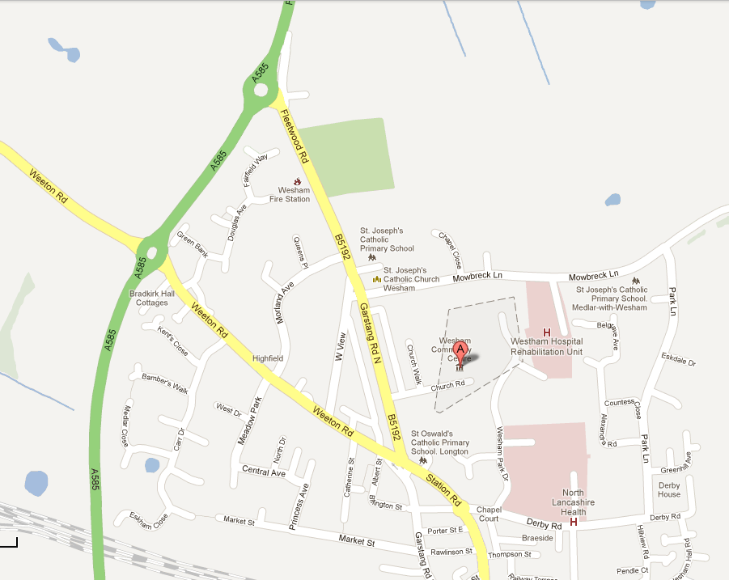
1st Kirkham & Wesham Scout HQ
PR4 3DT
To M55 J3

Directions from M55 motorway Junction 3 are:

Come off M55 head in direction of Kirkham. A585

At roundabout take 1st exit heading towards Kirkham town centre B5192 (Fleetwood Road becomes Garstang Road North)

Go past children's playground, St Josephs Church and Mowbreck Lane on your left

Church Road is 2nd road on left off B5192 Christ Church is on the corner.

Scout Centre at end of road next to Community Centre.

Any problems on the evening please ring Fiona Jackson on 07752 712970

