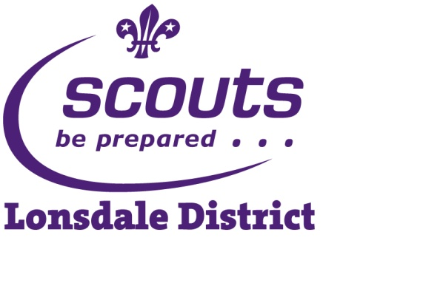
Christmas Post

Stamps 30p
Registered Charity No. 1027167

POSTING DATES NOV 26 to DEC 14
ALL CARDS DELIVERED BY CHRISTMAS EVE

LOCAL AREA ONLY

Aldcliffe, Arnside, Aughton, Bolton-le-Sands, Borwick, Brookhouse, Capernwray,
Carnforth- Town only, Caton, Claughton, Conder Green, Crag Bank, Crook of Lune,
Denny Beck, Ellel, Farleton, Forton, Galgate, Glasson Dock, Halton, Hazelmount, Hest
Bank, Heysham, Hornby, Lancaster, Littledale, Melling, Middleton, Millhead,
Morecambe, Nether Kellet, Over Kellet, Overton, Priest Hutton, Silverdale, Slyne, Stodday,
Sunderland Point, Tewitfield, Thurnham, Warton, Wray
CARDS WITH ADDRESSES OUTSIDE THIS AREA
WILL NOT BE DELIVERED
USE ONLY SCOUT POST BOXES NOT FOR USE IN ROYAL MAIL POST
THIS OFFER FOR CHRISTMAS GREETING CARDS ONLY

STAMPS MAY BE BOUGHT FROM:

