24th WORLD SCOUT JAMBOREE 2019

Don’t miss out on the adventure of a lifetime at the 24th World Scout Jamboree taking place in West Virginia, USA in 2019. Lonsdale District are looking for 5 young people to send to the next World Scout Jamboree…

This is a once in a lifetime experience to share a camp with 40,000 Scouts and Guides from across 150 countries and territories from around the world! In West Lancs, we have space to take 36 young people for their biggest adventure yet. Due to the age restrictions and the fact World Scout Jamborees only happen every four years, young people only get one opportunity to attend a World Scout Jamboree. So, it really is a once in a lifetime opportunity.

- To be eligible as a youth participant at the 24th World Scout Jamboree, you must have been born between 22 July 2001 and 21 July 2005.

- The Jamboree will take place from 22nd July to 2nd August 2019. Further activities will be built around these core dates. This will most likely include a couple of days in city the USA and also Hosted Hospitality in the USA or Canada to visit to another Scout group.

- Participants will fly to the USA

IMPORTANT INFORMATION

- The deadline for applications is 11th February 2018. Late applicants won’t be accepted.

- All applicants will be invited to and must attend a selection weekend at Silverhelme Scout Activity Centre Saturday 24th - Sunday 25th February 2018.

- The cost of a jamboree should never be an obstacle to stopping a young person applying. Two thirds of the cost is covered by West Lancs & Lonsdale Scouts. Scouts will have plenty of time to fundraise the rest with the support of Jamboree Co-ordinators

A WORLD SCOUT JAMBOREE?

The 24th World Scout Jamboree West Virginia 2019 will be a gathering of Scouts from almost every country in the world, and it really will be the experience of a lifetime for those lucky enough to take part. It’s bigger than the Olympics, both in terms of the number of participants and also in the number of countries represented. You’ll live and take part in adventurous activities alongside Scouts from all over the world, making new friends and experiencing different cultures you never knew existed!
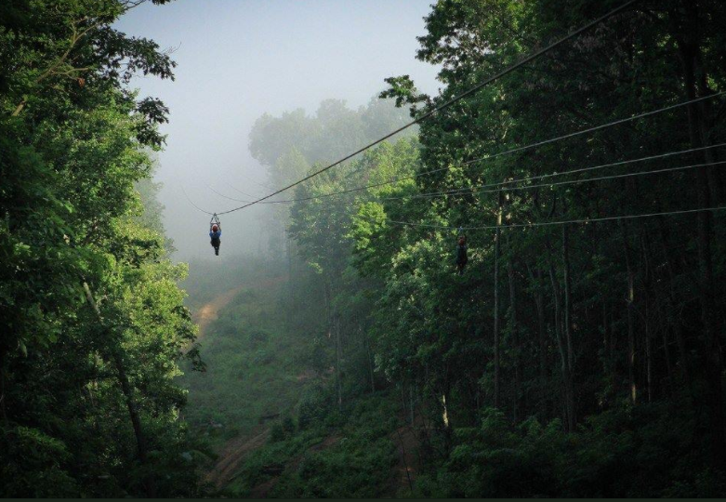
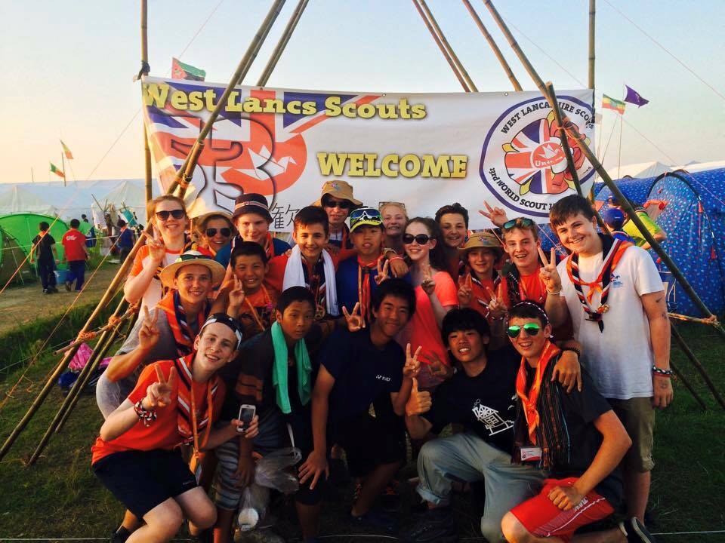
For the first time, a World Scout Jamboree will be hosted by three National Scout Organisations and the three distinct Cultures will join together to host Scouts in celebration of cultural exchange, mutual understanding, peace and friendship. The 24th World Scout Jamboree will take place at the Summit Bechtel Reserve in West Virginia, which is 10,000 acres of awesome (http://www.summitbsa.org). The jamboree site is the size of London!! The jamboree site will be hilly, and so physical fitness will be important. It is expected that there will be about an hour walk to activities each day. Over $500 million has been invested into the site and so the activities on offer are better than you can even imagine! White water rafting, a 5 mile zip wire and over 100 climbing stations on site!! Make sure you have a look at the website.
YOUR JAMBOREE TEAM

UNIT LEADERS
Your unit leaders will support you throughout your jamboree adventure, help you prepare, ensure you get as much out of the experience as possible, as well as making sure you have lots of fun, develop life-long relationships and develop personally. The Unit Leader is Craig Dewar (from Lonsdale), and he is supported by a team of Assistant Leaders: Oliver Wood, Alison Walmsley and Karl Street (Left to Right)

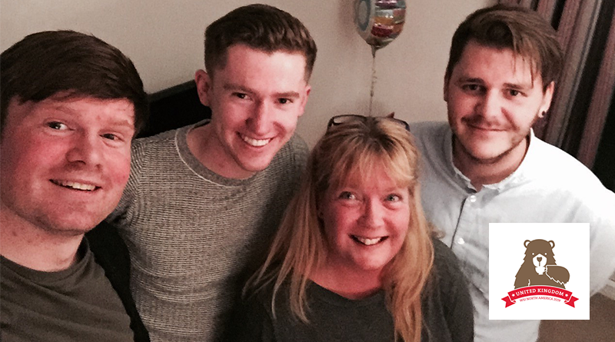

DISTRICT JAMBOREE COORDINATORS

To support you on your Jamboree Journey, Steph Stephenson and Debbie Smith have been appointed to work with you locally. They will support you with fundraising, and in promoting the Jamboree across the District.

What we are looking for…

Interested? We’d encourage you to make an application.

To help you with your application we’d point out the following:

- Make sure you can attend the selection weekend (details of this will be sent on receipt of your application.)
- Make sure you can attend all the Mandatory Jamboree Dates listed below.
- Make sure your parents support your application, and they’re prepared to help support you with fundraising and the meeting/training weekend commitments.
- The Jamboree is a physically demanding site in a hot climate – you need to be physically fit and healthy to make the most of the experience.
- Check out the selection criteria below to see if you fit the bill:

Skills | Behaviour
Ability to work with others and form friendships | Cooperation
Commitment to include others, listen and value others | Respect
Demonstrate the importance of being honest, trustworthy and loyal | Integrity
Help other people / look after surroundings | Care
Express their views and take time to hear others | Communication
Willing to take responsibility (for themselves, possessions and tasks) and make choices | Responsibility
Demonstrate willingness to participate, learn by doing and have fun | Participation
Commitment to the Jamboree experience, including training events | Participation
Open and willing to explore faiths, beliefs and attitudes, including those that are different then their own | Belief

MANDATORY TRAINING DATES

There will be various meetings and training events between now and November 2019, all of which you will be required to attend. If you are applying to be a member of the Jamboree Unit, you will be expected to attend all of the following dates.

Wednesday 18th April 2018 - Parents & Young People meeting 1 - 7:30pm

Saturday 7th July 2018 - Training day 1

Friday 28th - Sunday 30th September 2018 - Training Weekend 1

Friday 14th - Sunday 16th December 2018 - Training Weekend 2

Friday 25th - Sunday 27th January 2019 - Training weekend 3

Friday 1st - Sunday 3rd March 2019 - Training weekend 4 (camping)

Friday 3rd to Monday 6th May 2019 - Training weekend (camping)

Wednesday 26th June 2019 - Parents & Young People meeting 2 - 7:30pm

Friday 5th - Sunday 7th July 2019 - Training weekend 6 (camping)

Friday 4th to Sunday 6th October 2019 - Reunion Weekend

Wednesday 13th November 2019 - Final Presentation

THE APPLICATION

- Please make sure that the Young Person completes this application.
- Complete all parts of the form in the best you can.
- Be sure to tell us what you’ll gain from a jamboree experience and how it will help your personal development.

 | PERSONAL INFORMATION
First names
Surname
Troop / Unit
Address

Postcode
Date of Birth | Must be between 22nd July 2001 and 21st July 2005 (inclusively)
Disabilities or SEN
Home Telephone
Parent Mobile
Parental Email Address
Time in Scouting | Must currently be either a Scout or Explorer / Young Leader in Lonsdale District

YOU & THE JAMBOREE
Please explain why you are applying to join the Jamboree Unit and what special qualities you could bring to the experience.
Tell us about your previous Scouting experiences and how they have benefitted you.
What is your favourite Scouting experience to date and why?

TROOP / UNIT LEADER REFERENCE
This leader will be contacted to give information to support your application.
NAME:
CONTACT EMAIL:
CONTACT PHONE:

PARENTAL PERMISSION
It is expected that parents’ fully engage in supporting you through this process. That will involve attending meetings and supporting your fundraising.
NAME:
CONTACT EMAIL:
CONTACT PHONE:

PARENT SIGNATURE: (in the absence of a signature the form should be submitted from a parents’ email address) |  | I give my full permission for my son / daughter to apply to take part in the 24th World Scout Jamboree 2019.

SEND YOUR APPLICATION
Email your application to steph@stephensonsdairy.co.uk before 17:00 on the
11th February 2018.
This is a very exciting and life changing opportunity that for those who attend, will never forget! We look forward to receiving your application and good luck!

KEEP UP TO DATE:
Like West Lancs Jamboree Unit on Facebook: https://www.facebook.com/WLSJamboree

Follow West Lancs Jamboree Unit on Twitter:
https://twitter.com/WLSJamboree

Jamboree Website:
https://www.2019wsj.org/attend/participants/

